CS 255 System Design Document

UML Diagrams

UML Use Case Diagram
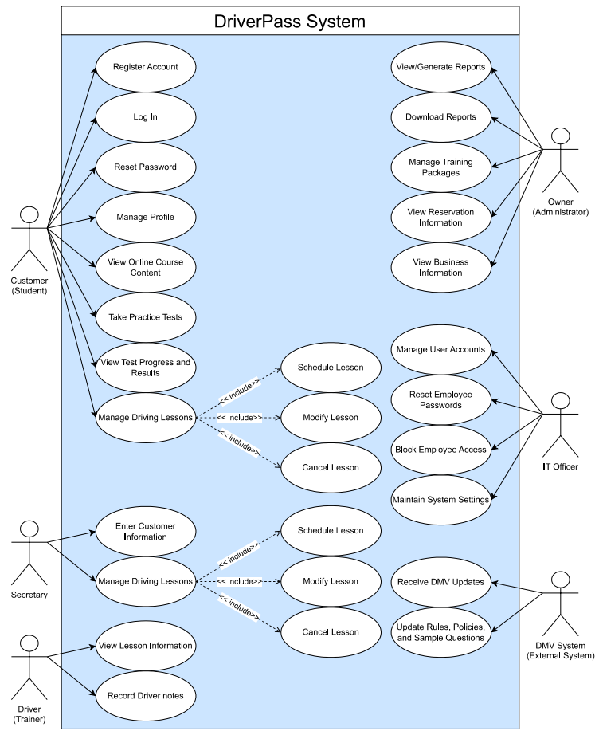

UML Activity Diagrams
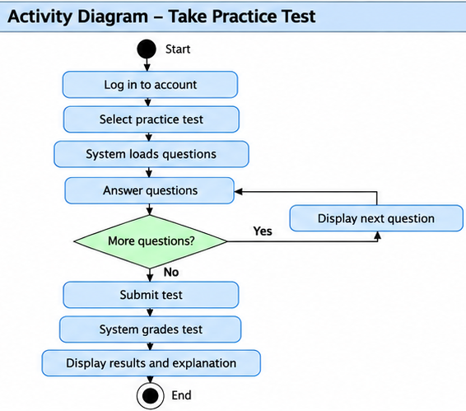
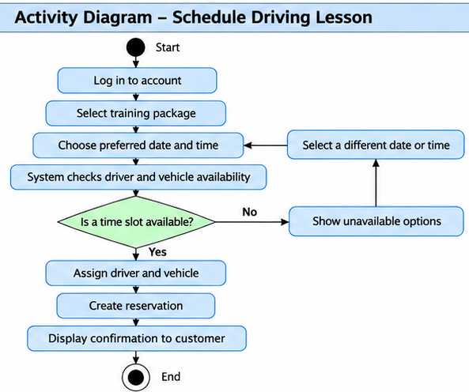

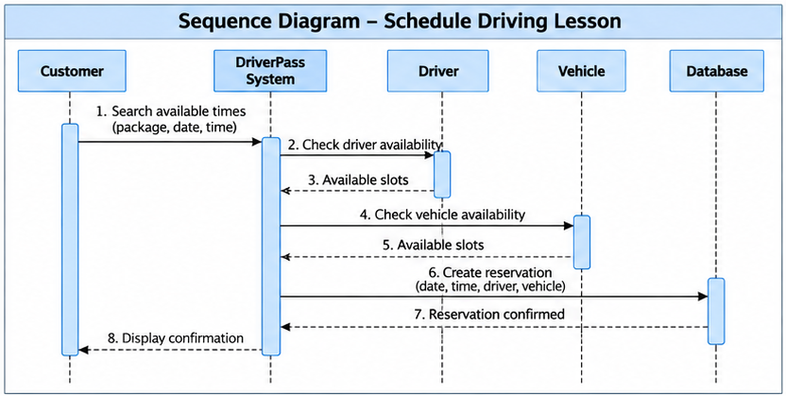
UML Sequence Diagram

UML Class Diagram
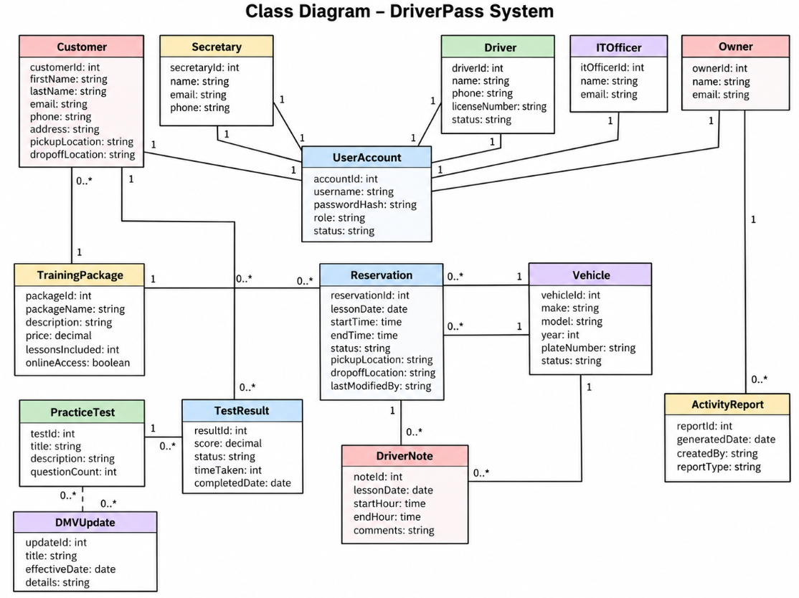

Technical Requirements
- Hardware: Customers and employees should be able to access DriverPass using standard computers, tablets, or mobile devices with an internet connection.
- Software: The system should run as a web-based application through common web browsers. A centralized database will be needed to store customer accounts, reservations, training packages, test results, driver notes, and activity records.
- Cloud infrastructure: DriverPass prefers cloud hosting so backups, availability, and much of the underlying infrastructure can be managed outside the local business.
- Security: The system should require user authentication and role-based access so customers, the secretary, drivers, the owner, and IT staff only have access to the functions they need. The IT officer must also be able to reset passwords and block access when necessary.
- Data protection: Customer account and payment information should be protected during storage and transmission. Using encrypted web connections would be an appropriate design choice for this.
- External integration: The system needs a way to receive updated DMV rules, policies, and sample questions and notify DriverPass when updates are available.
- Reporting: Authorized users should be able to generate and download reports for use in programs such as Excel.
- Internet connectivity: Users must be online to modify system data so DriverPass does not end up with conflicting versions of the same information.

